**Requesting Security Roles through IAM**

Log into IAM at <https://oim.iam.wisconsin.edu/xlWebApp/>

Select your campus

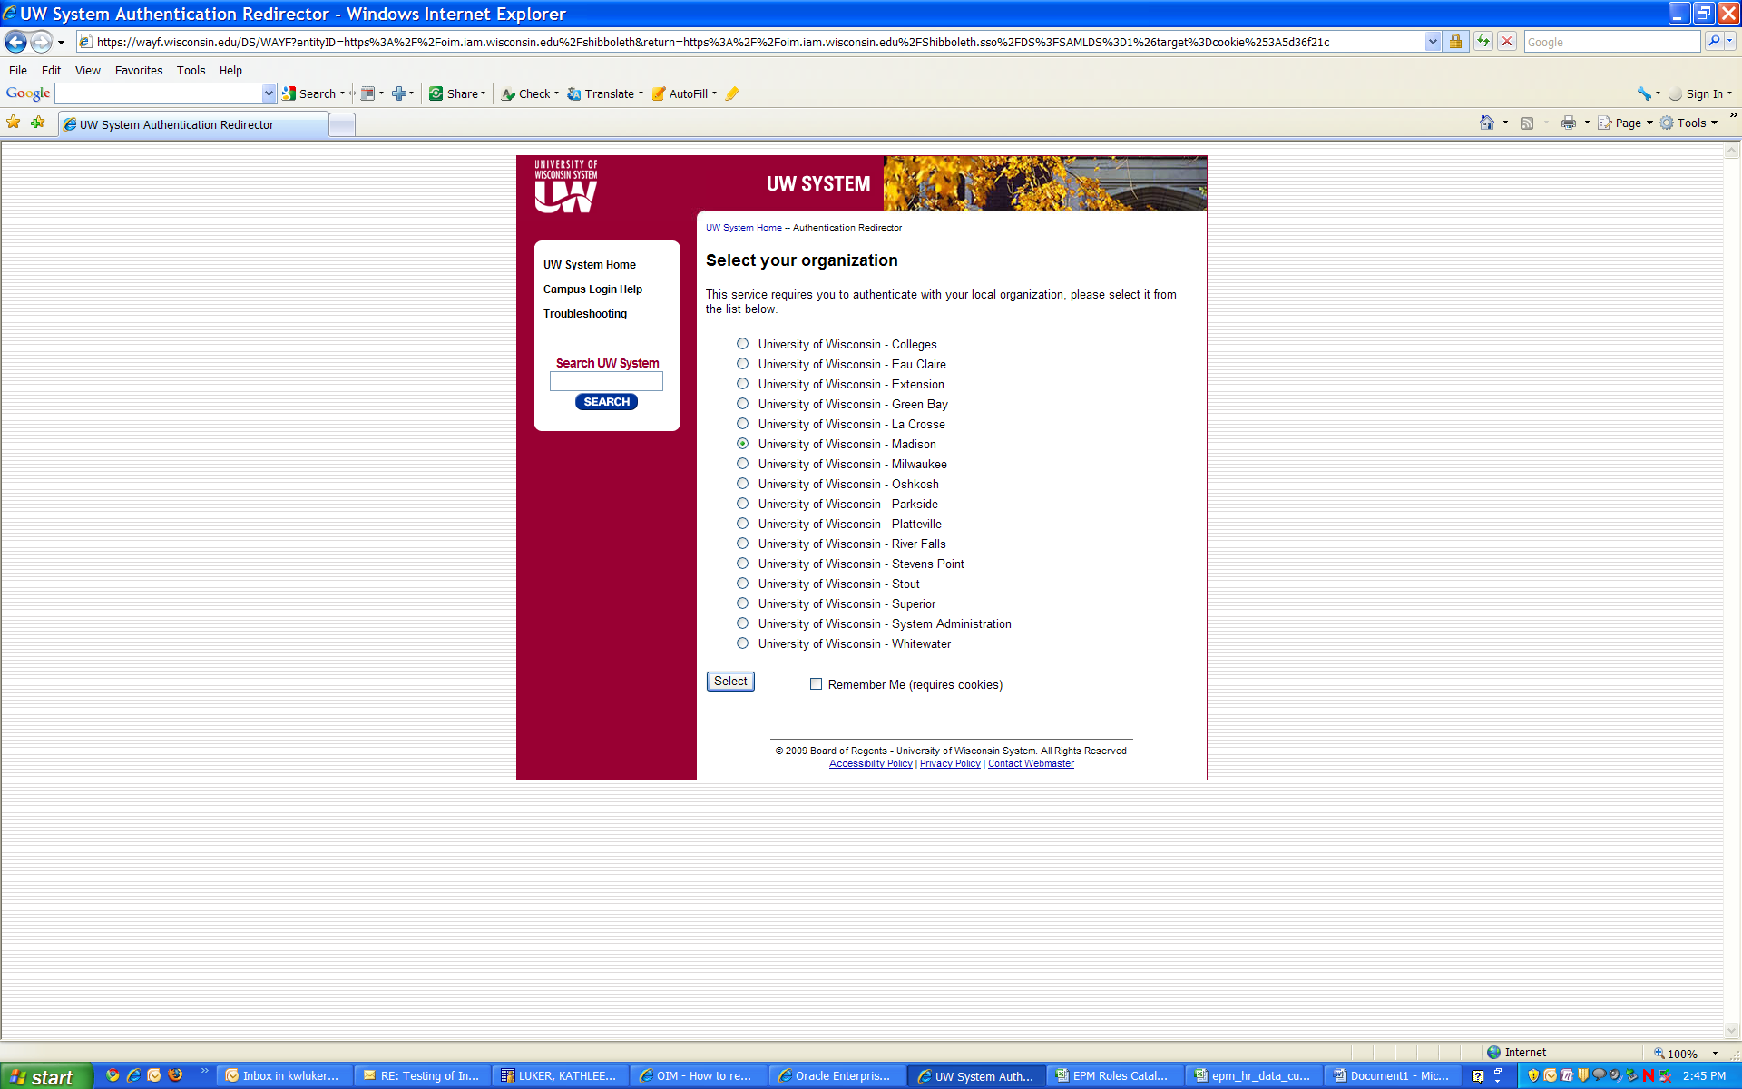

Log in using your campus credentials; (click ‘yes’ if you get trusted sites security warnings)

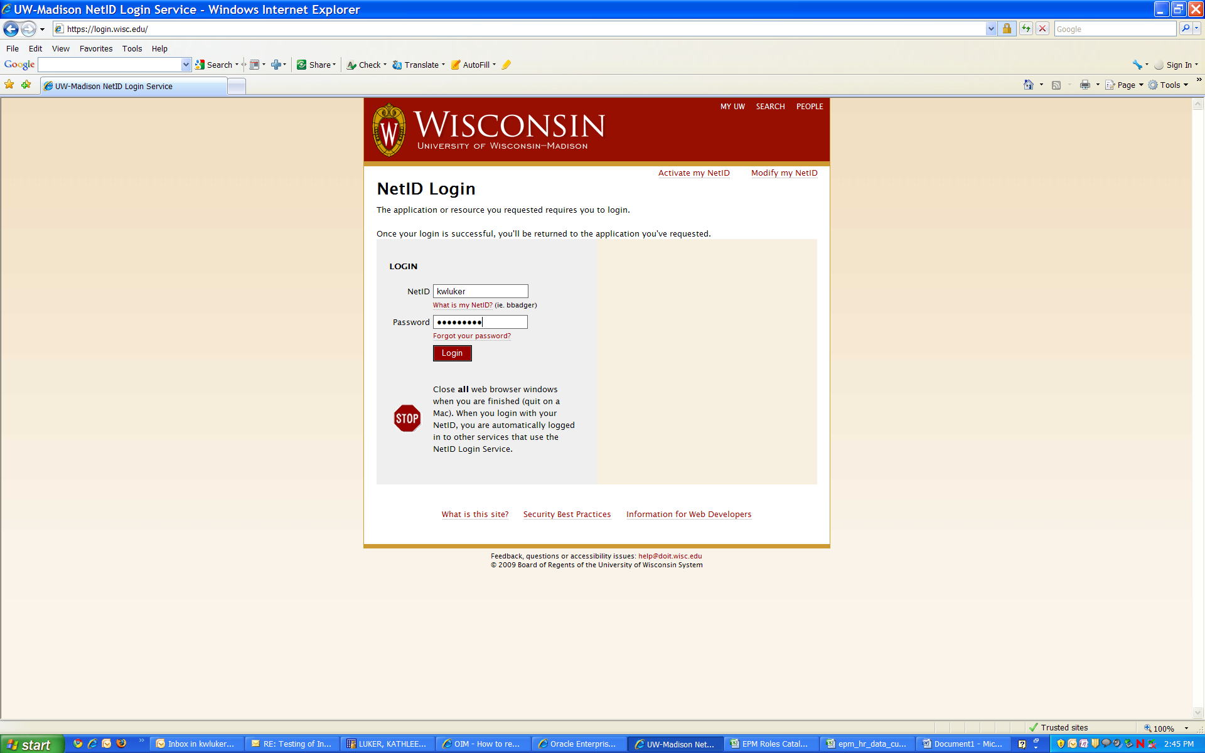

Click requests, then request resources

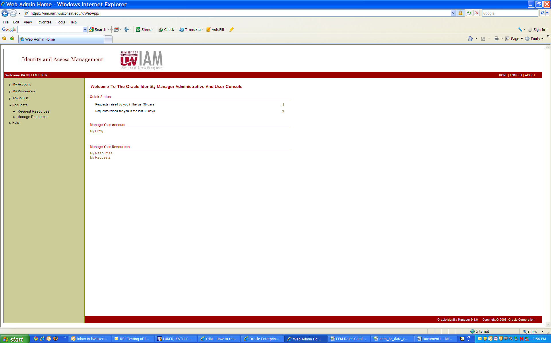

Click the Myself radio button

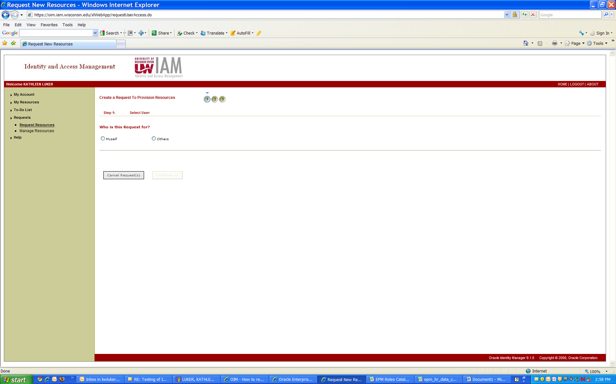

Click continue

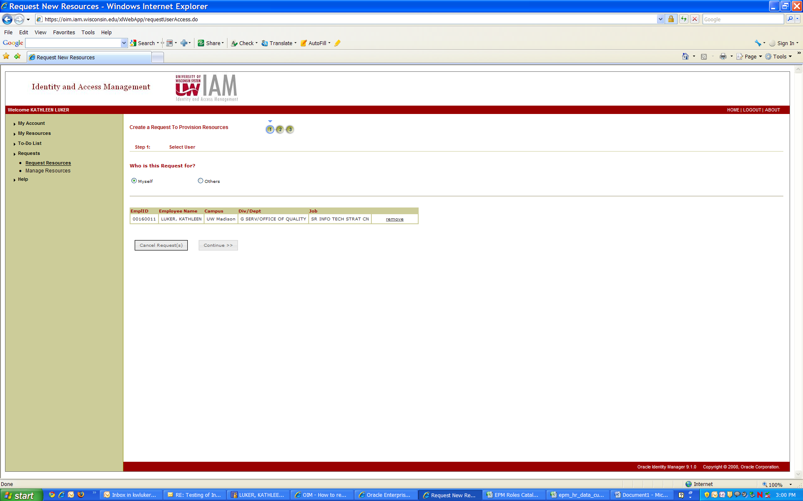

Click search

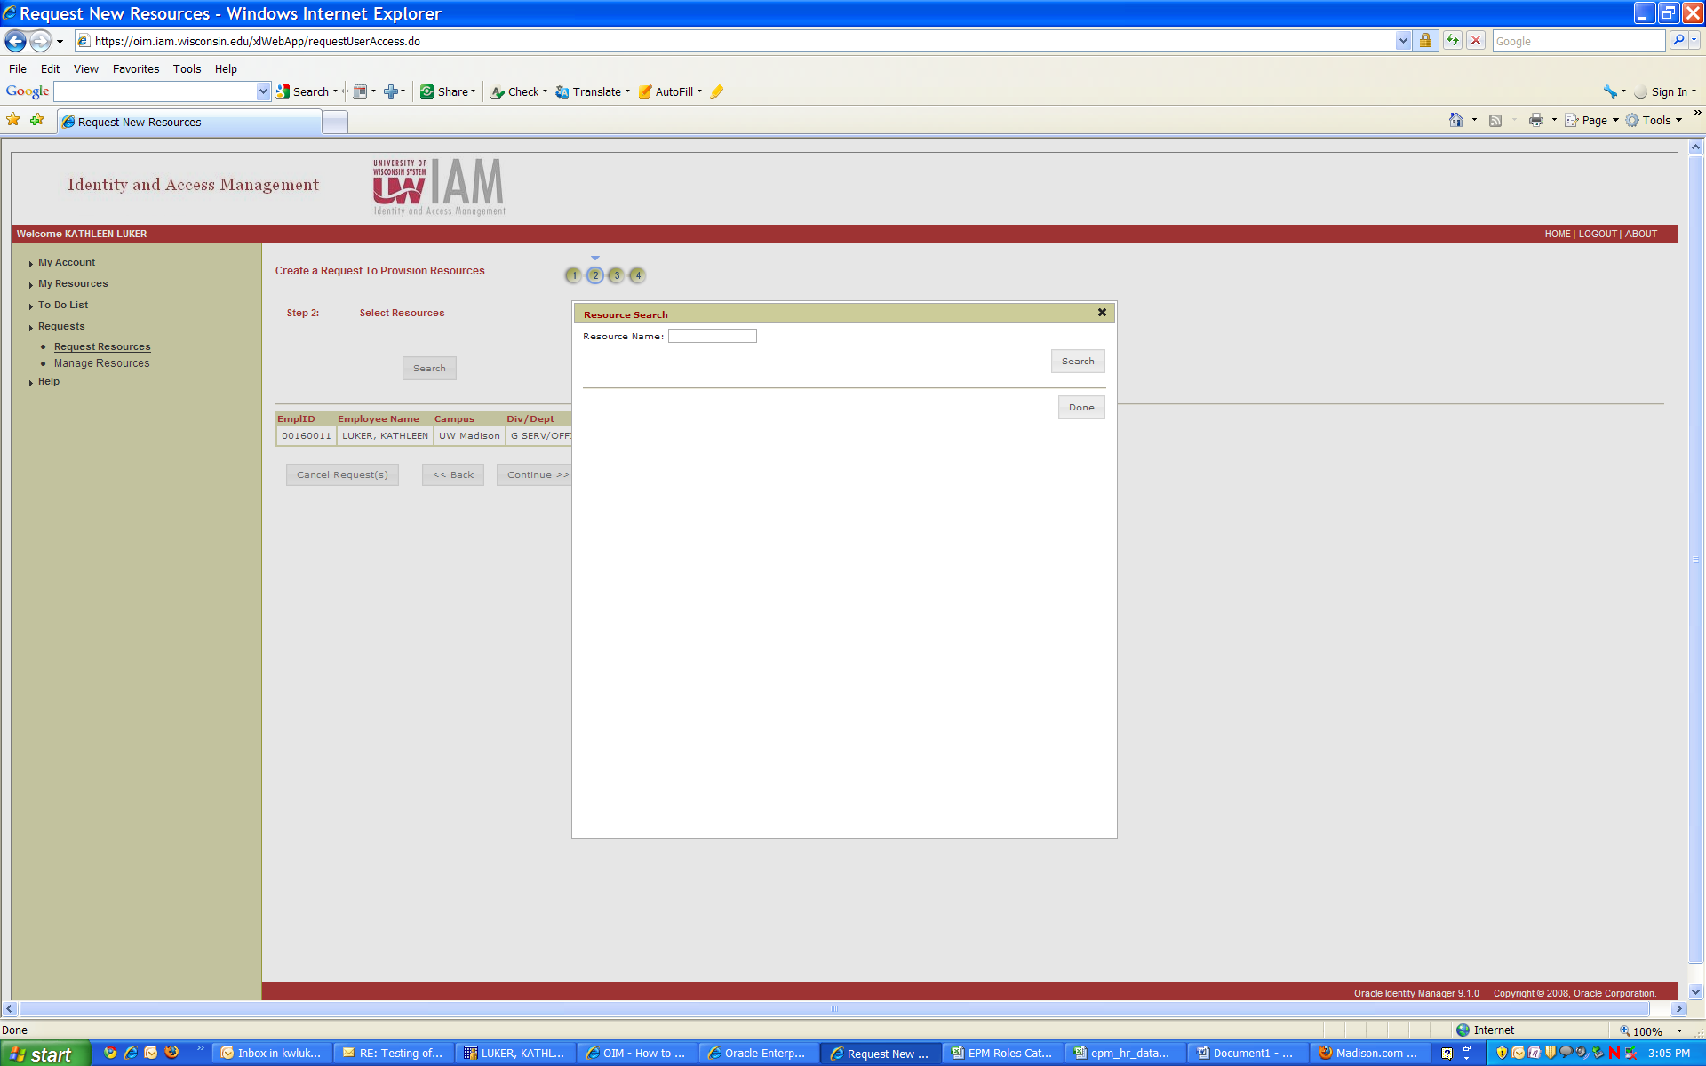

Select PSFT UM Server and click Done

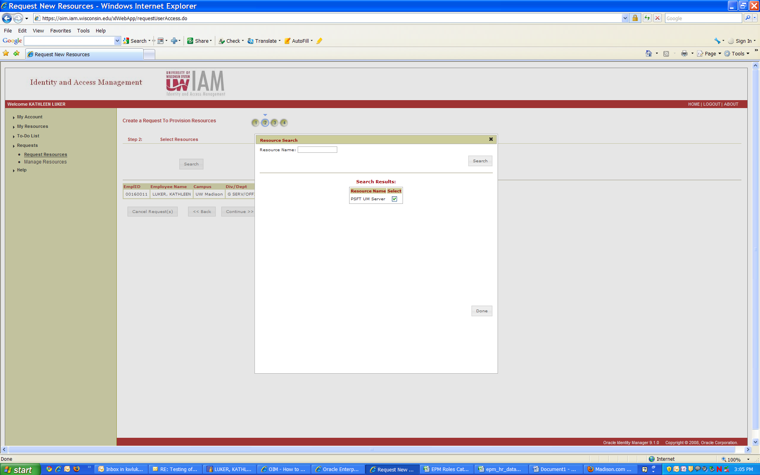

Click Add

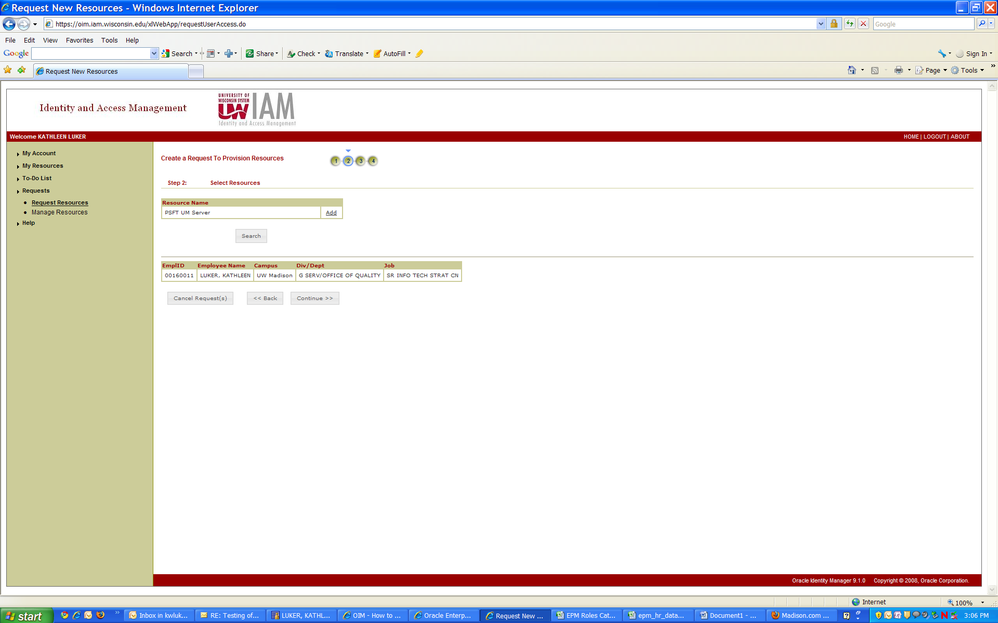

Enter your supervisor, leave level of data access as is, put IR in filter and scroll down to all of the IR roles (they will be all together).

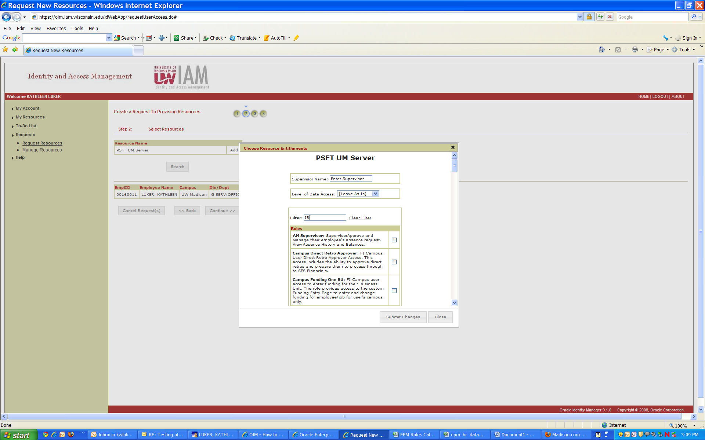

Select the roles you want and click submit changes

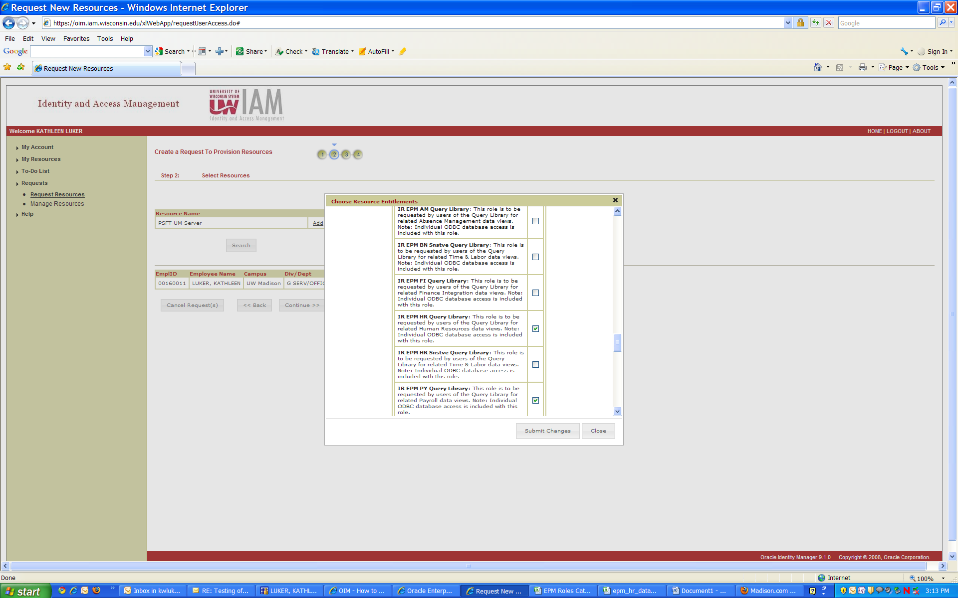

Enter supervisor and click continue

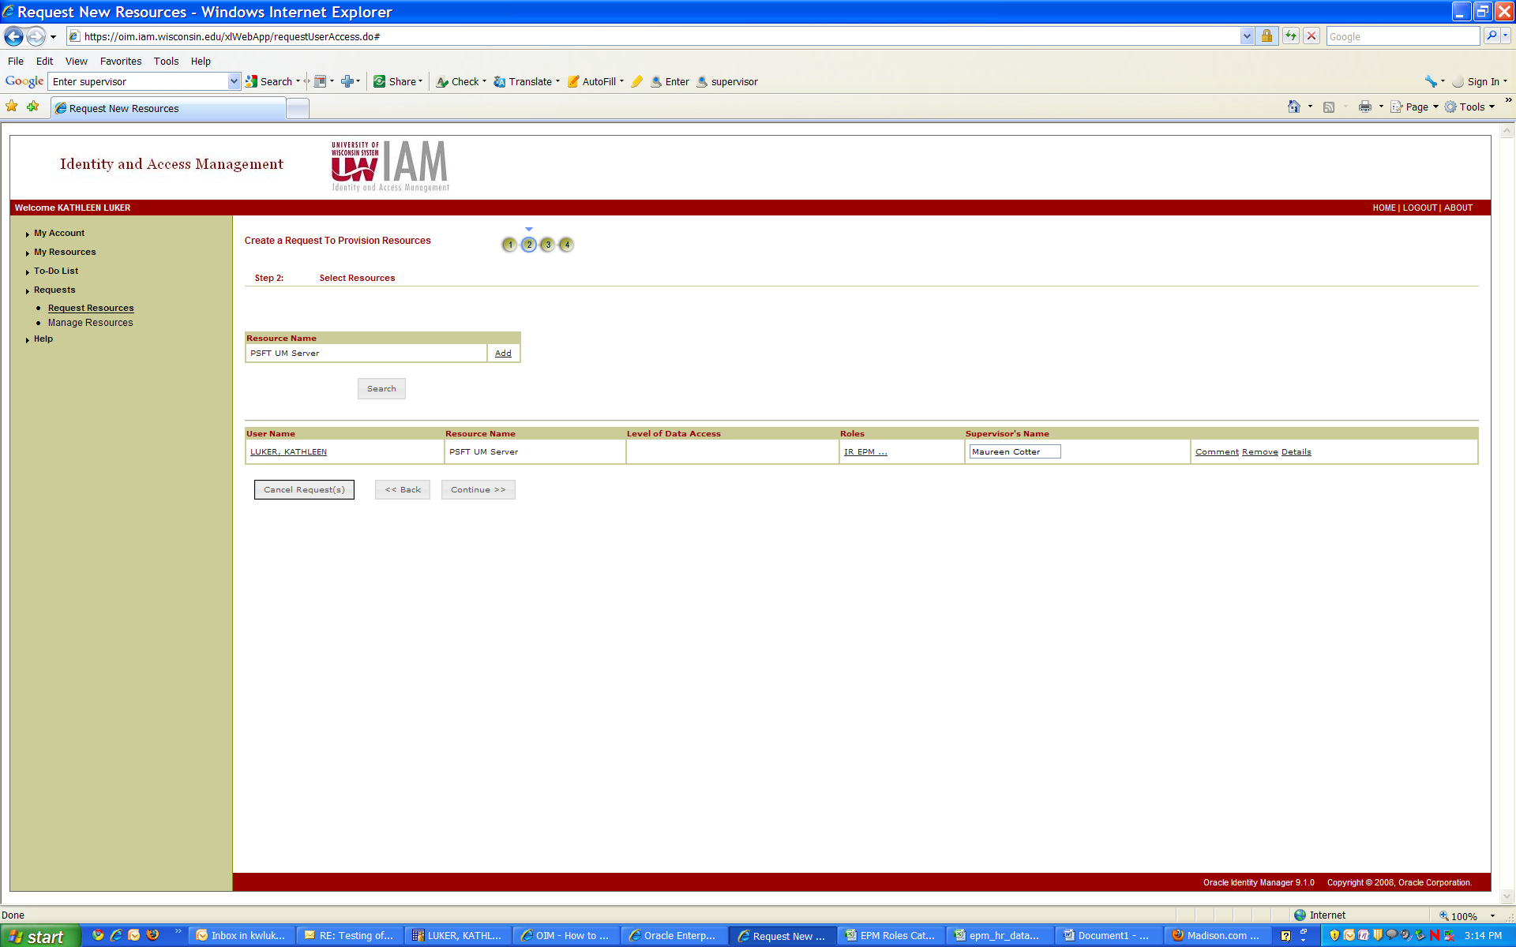

Read and agree to compliance agreement, click continue

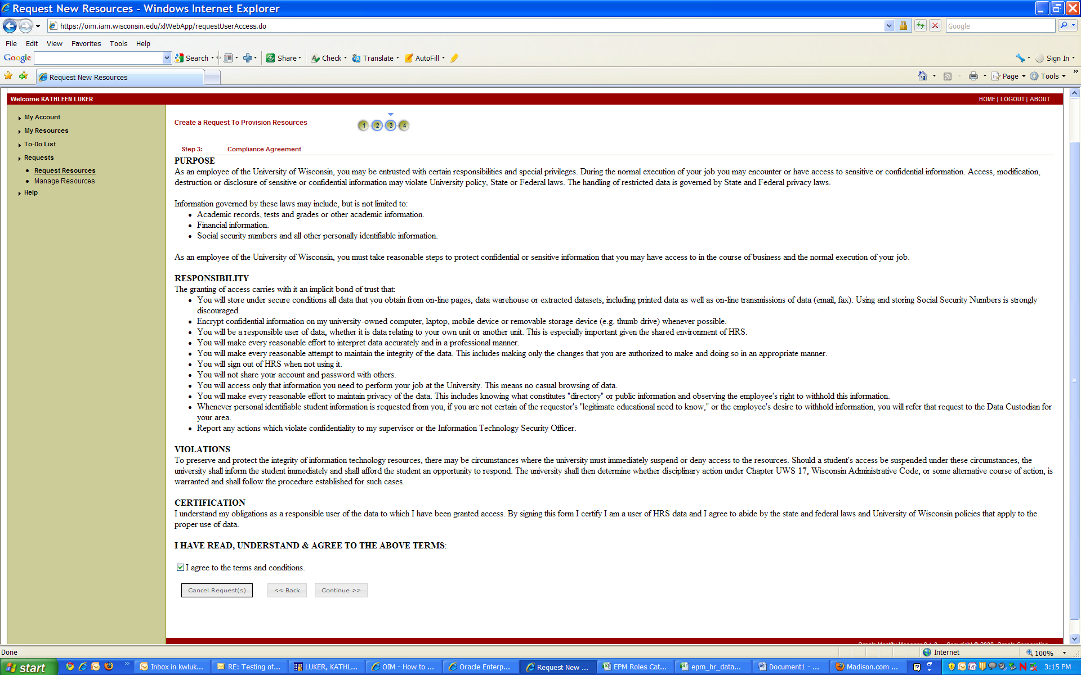

Click submit now

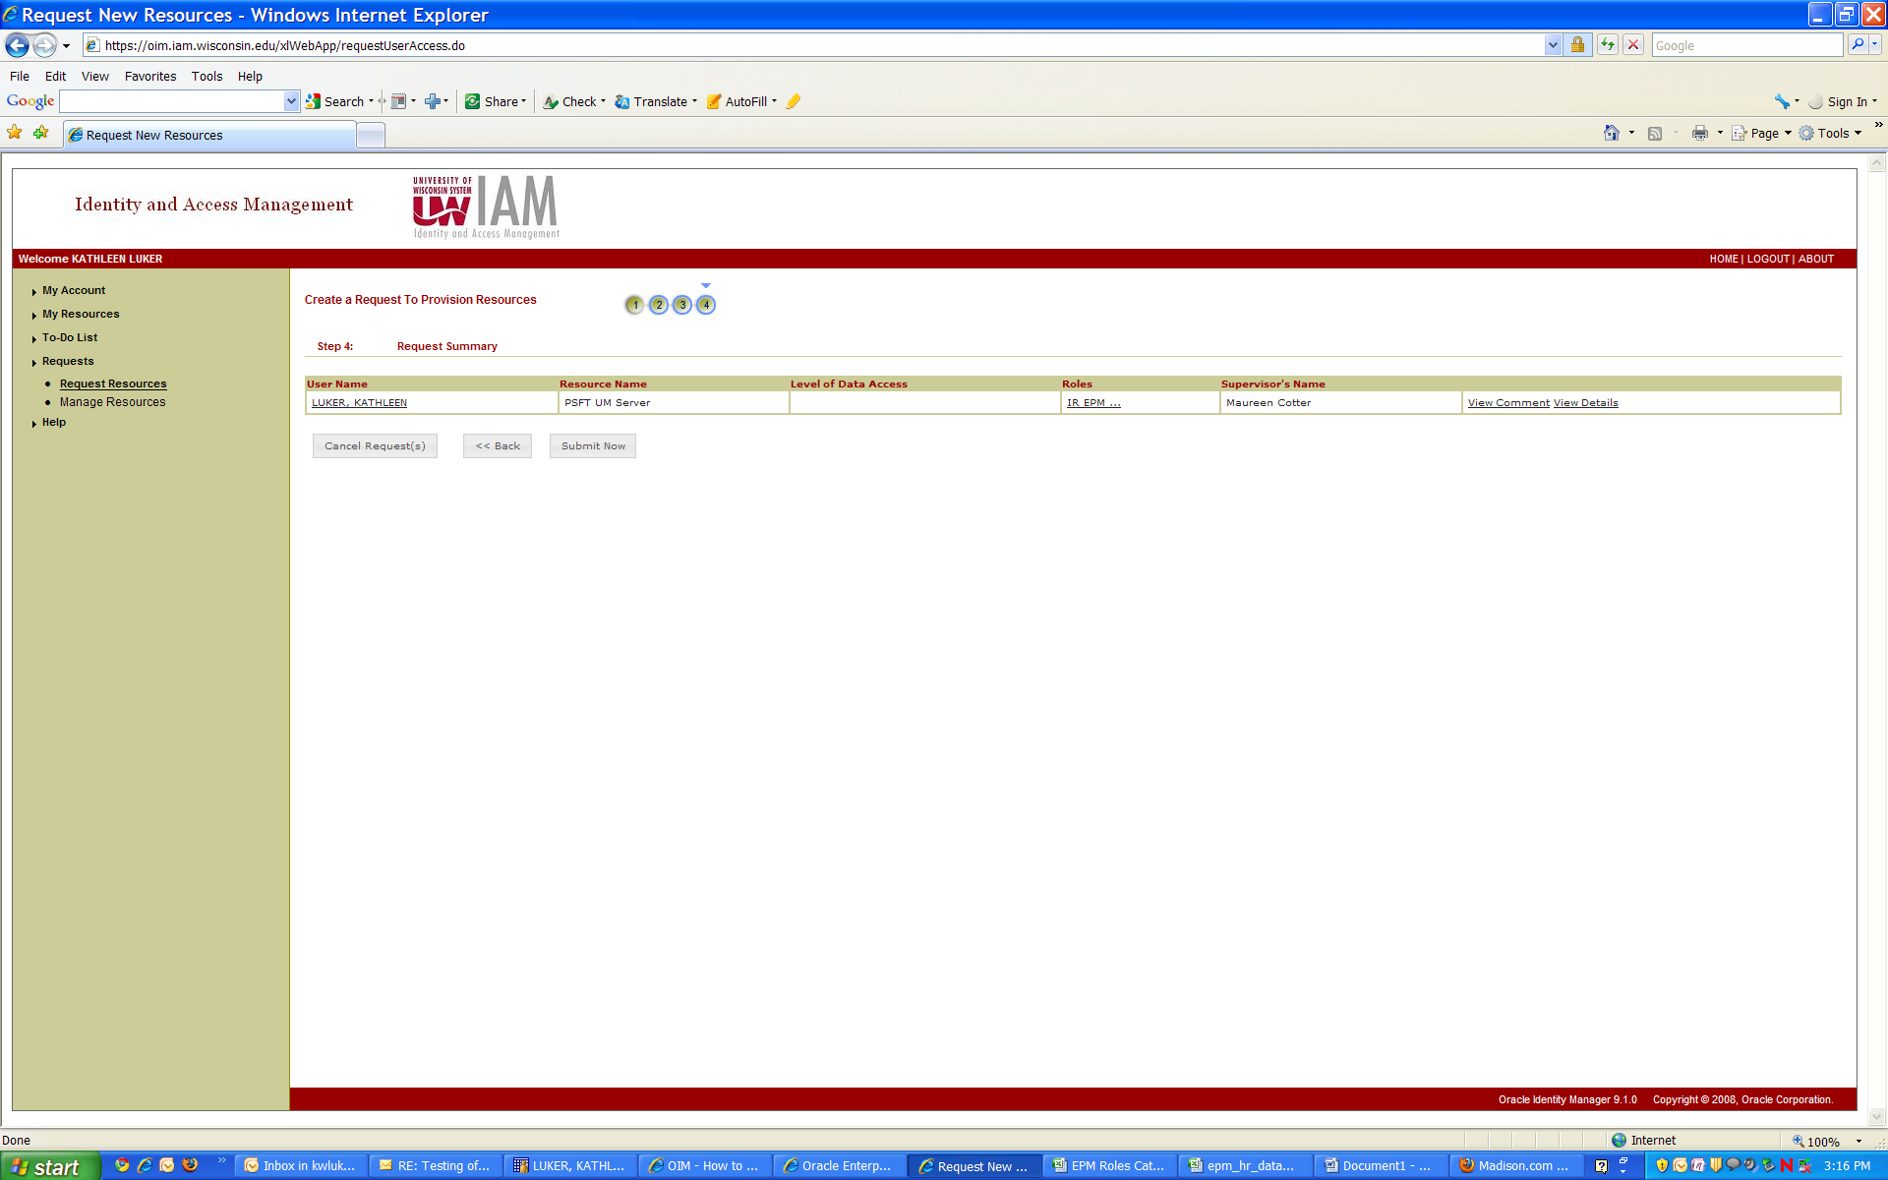

Wait for your request to be submitted successfully and log out.