

**School of Education Administrative Forum**

**Thursday, August 15, 2013**

**Wisconsin Idea Room, 159 Education Building ⚫ 9:30 a.m.**

**Agenda**

* Updates & Announcements – All
* Budget Update & Pay Plan Implementation – Staci and Melissa
* HR and Payroll – Sarah, Staci, Christy

-Rehired Annuitant Changes <http://etf.wi.gov/news/ht-act20faqs.htm>

-Benefits

<https://www.ohrd.wisc.edu/home/HideATab/ConferencesSpecialEvents/EmployeeBenefitsandResourceFair/tabid/176/Default.aspx>

* 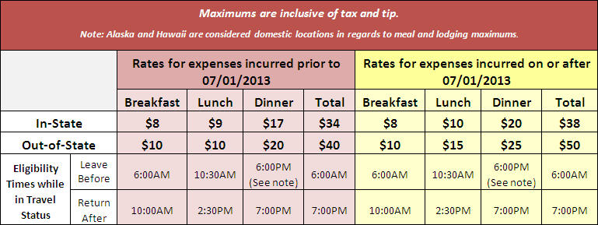Financial Management – Toby  
  -Concur for travel - <http://www.bussvc.wisc.edu/acct/travel/tabconcur.html>   
  -Meal max changes - <http://www.bussvc.wisc.edu/acct/policy/travel/meals.html>
* Facilities – Jesse  
  -Access Control Demo   
  <http://businessoffice.education.wisc.edu/bo/building-services/key-and-access-request-forms>

-Construction Updates

***If there are any topics that you would like us to cover, or if you have suggestions for special guest or training opportunities that you would like to see at future forums, please let us know.***

## Melissa Amos-Landgraf Associate Dean for Administration (608) 262-4474

Staci Francis Assistant Dean for Human Resources (608) 262-6139

Sarah Gomez Rendon Human Resources Assistant Advanced (608) 262-4079

Dean Ladwig Financial Specialist (608) 262-6138  
Christy Moldenhauer Human Resources Assistant Advanced (608) 262-9149

## Toby Schellhase Accountant (608) 262-1765

Beth Walsh   Assistant Dean, Grants & Contracts (608) 263-5559

Jesse Winters Director of Facilities (608) 445-1878